LAB 1 - Git and GitHub Lab

Louis Philip Buenaflor

Professor, Katherine Argall

January 24, 2024

1. Configure Git  
   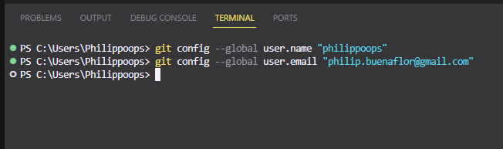
2. Create git Repository on GitHub  
   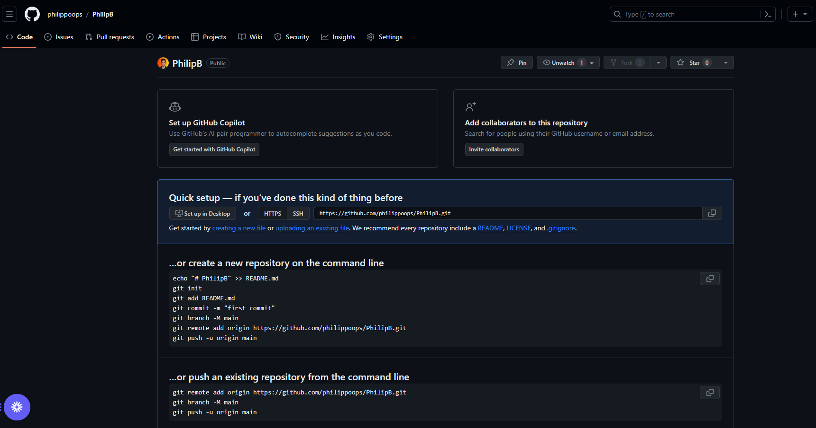
3. Create a file on my computer  
   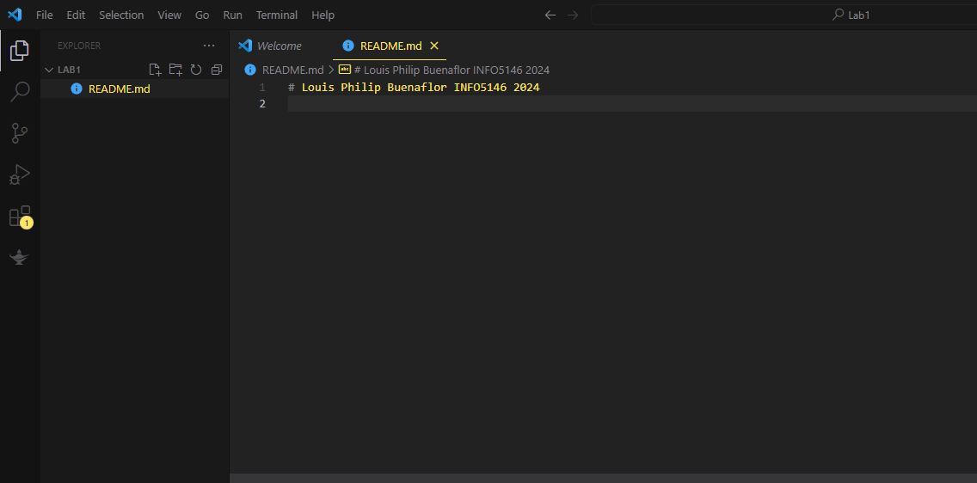
4. Initialize a git repository  
   